Receive up to $5000 in tax credit per single-family home and $1000 per multi-family unit for sealing and insulating with HBS spray foam!

The recently passed Inﬂation Reduction Act extends and enhances the 45L tax credit for builders. The enhanced 45L provision, known as the New Energy Efﬁcient Homes Tax Credit, increases the energy savings requirements to newer standards but offers a larger tax credit incentive.
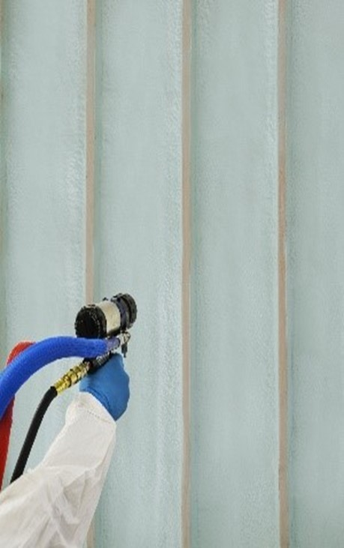
- Original 45L expired on December 31st, 2021, but is retroactive through December 31st, 2022
  - $2000 tax credit per home built in 2022
  - Must achieve >50% energy savings over the 2006 IECC
  - A minimum of 10% of energy cost savings is achievable by using spray foam insulation
The enhanced 45L provision, known as the New Energy Efficient Homes Tax Credit, increases the energy savings requirements to newer standards but offers a larger tax credit incentive.
- Enhanced 45L begins January 1st, 2023, through December 31st, 2032
  - $2500 per Single Family home, or $500 per Multi-family unit, that meets Energy Start 3.1.11
  - $5000 per SF home, or $1000 per MF unit, that meets DOE ZERH 1.7
  - 2012 IECC is the min requirement to qualify, but state and/or municipality adoption takes precedent
  - Builders must sign Energy Star Partnership Agreement to qualify for tax credits
  - All states will move to Energy Star 3.1.11 on 01/01/2023
  - CA, OR, WA, and FL already have state requirements
We can provide additional information on how HBS spray foam insulation can help qualify your homes. Contact us for more details.

To learn more about the 45L tax credit, click the link below or go to sprayfoamtaxcredit.com/45L.
Learn More​​​​​

